Patuakhali Science and Technology University

Dumki, Patuakhali-8602

Course code: **MAT-221**  
Course Title: **Mathematics-IV**

Submitted To

**Dr.Md.Masudur Rahaman**  
Professor  
Department of Mathematics  
Faculty of Computer Science & Engineering

Submitted By

Name: **YourName**  
Id: **YourId**  
Reg: **YourReg**  
Session: 2021-2022  
Faculty of Computer Science & Engineering

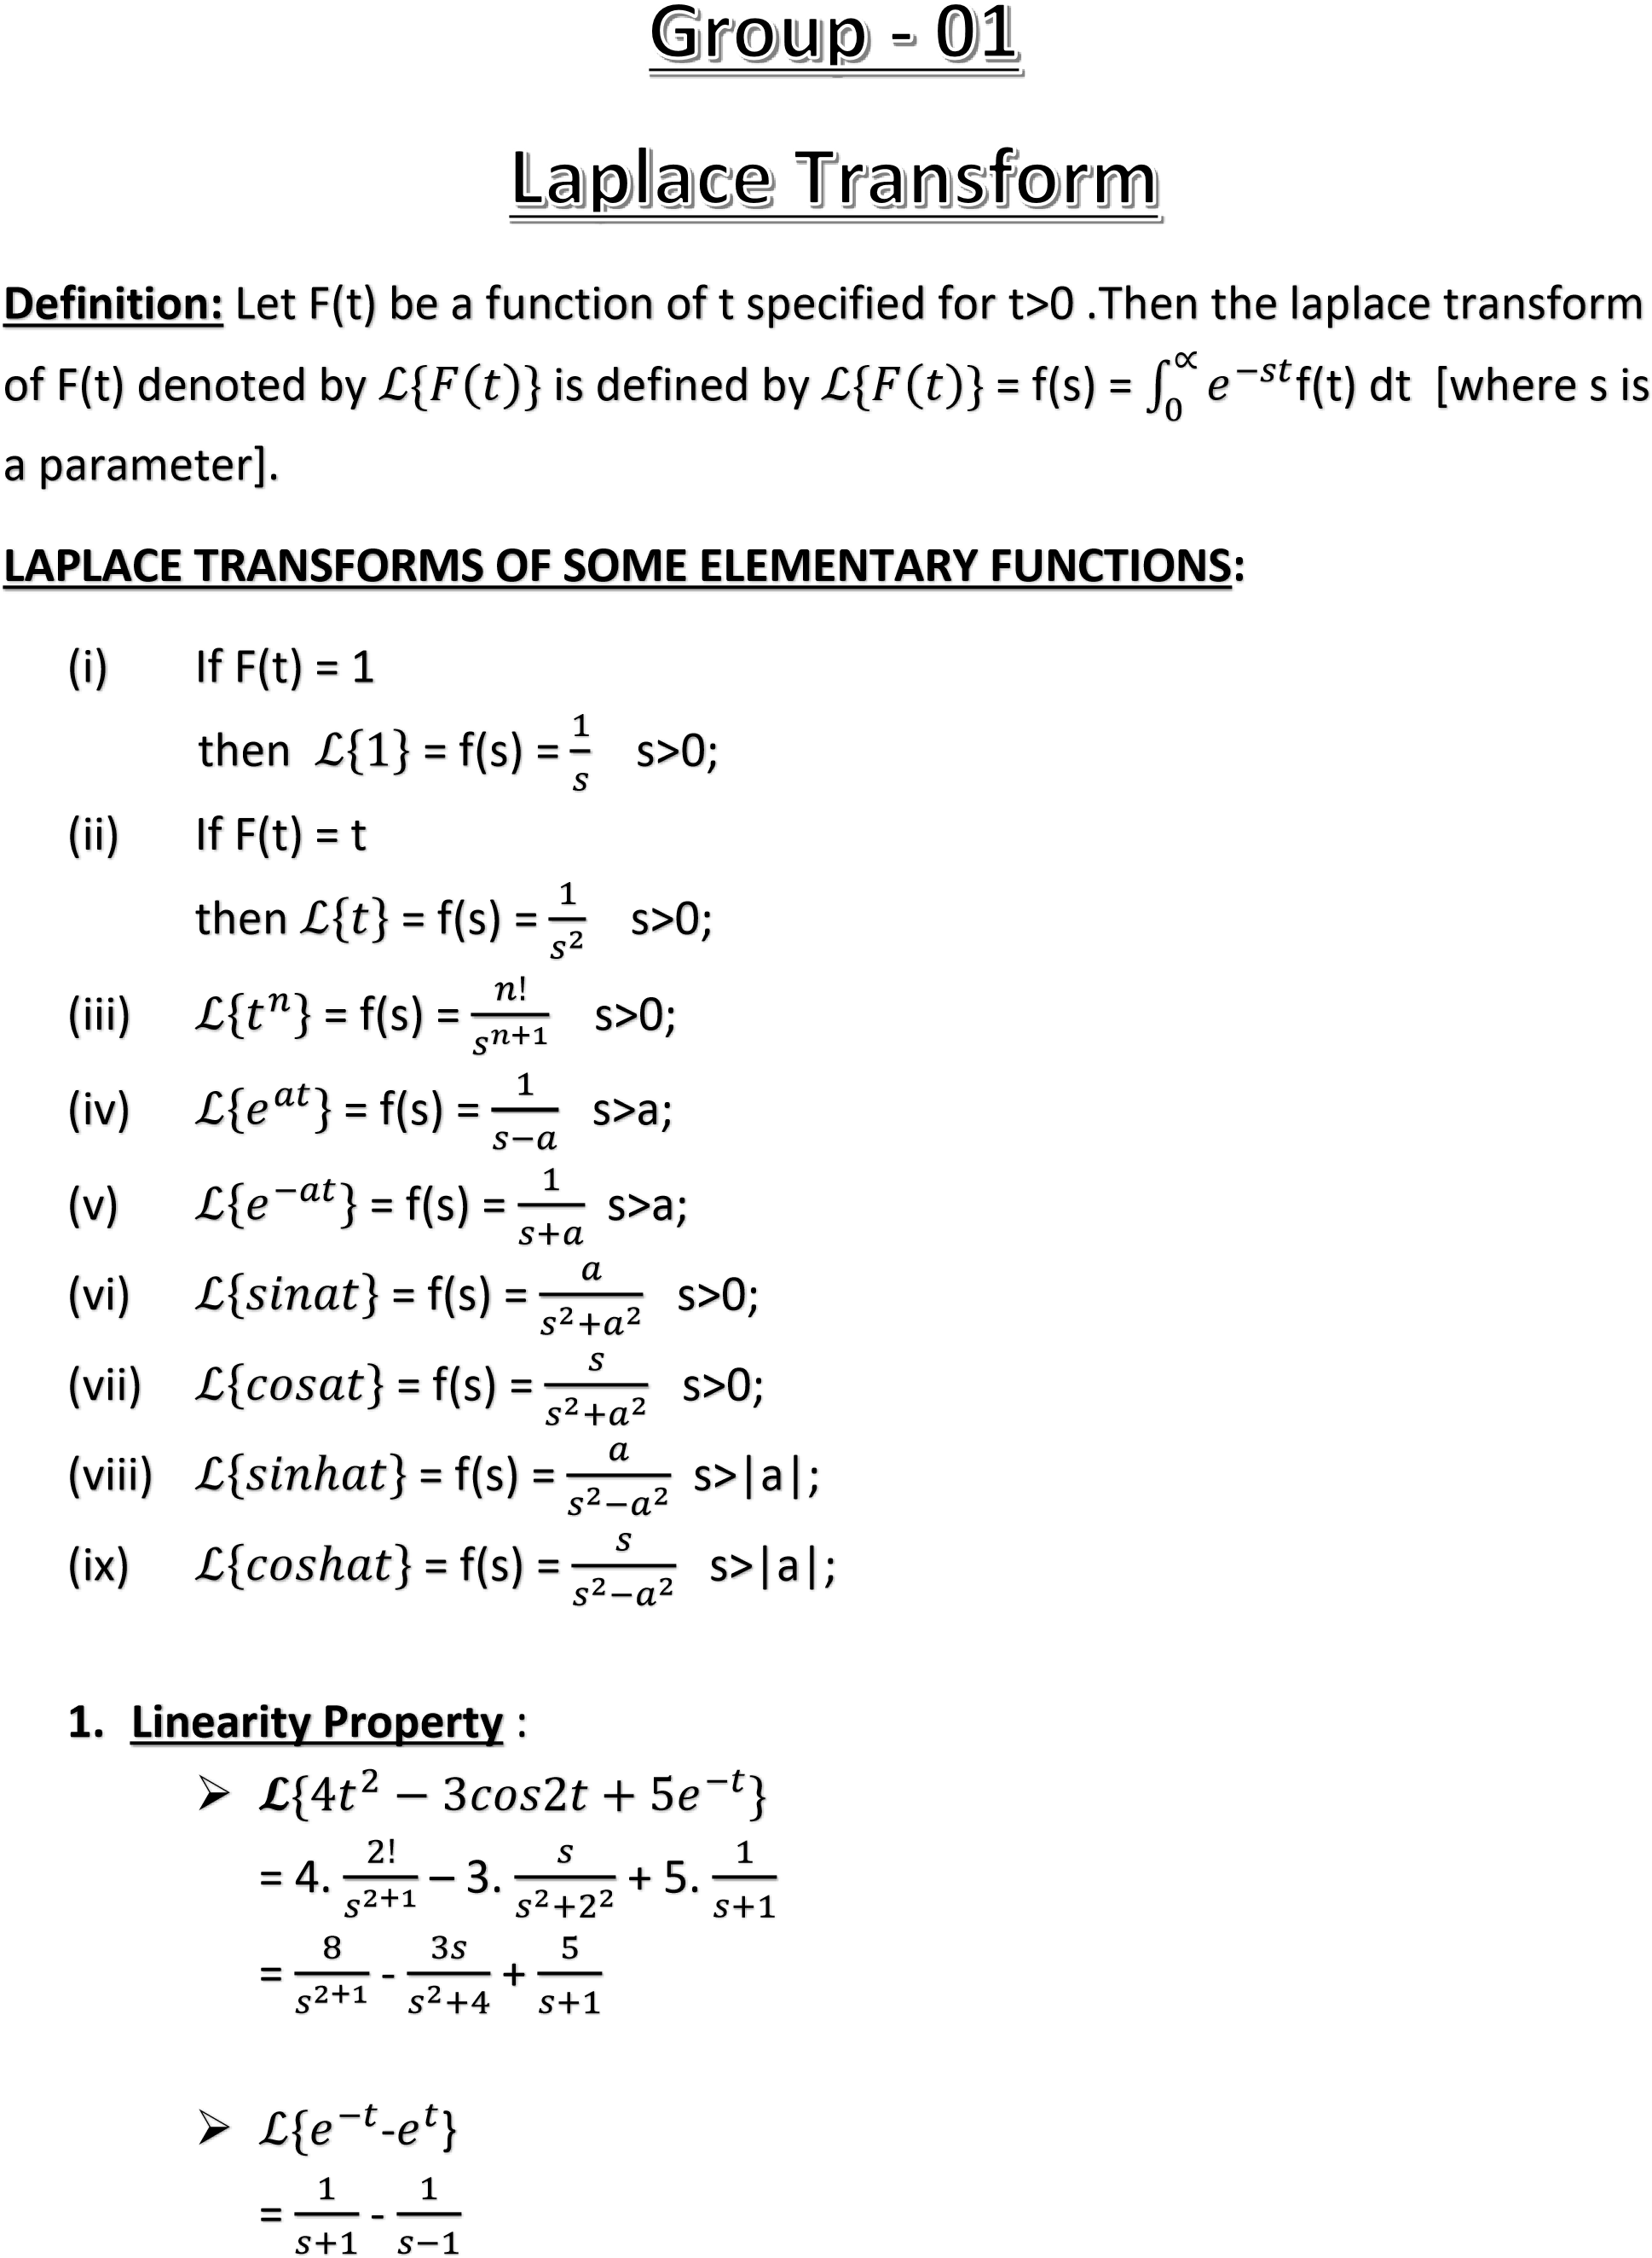

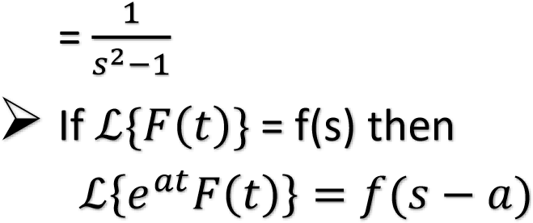

**Example – 01 : Find the laplace transform of the following function:** i. 𝑒𝑎𝑡 ii. 𝑒−𝑎𝑡

solve:

(i)

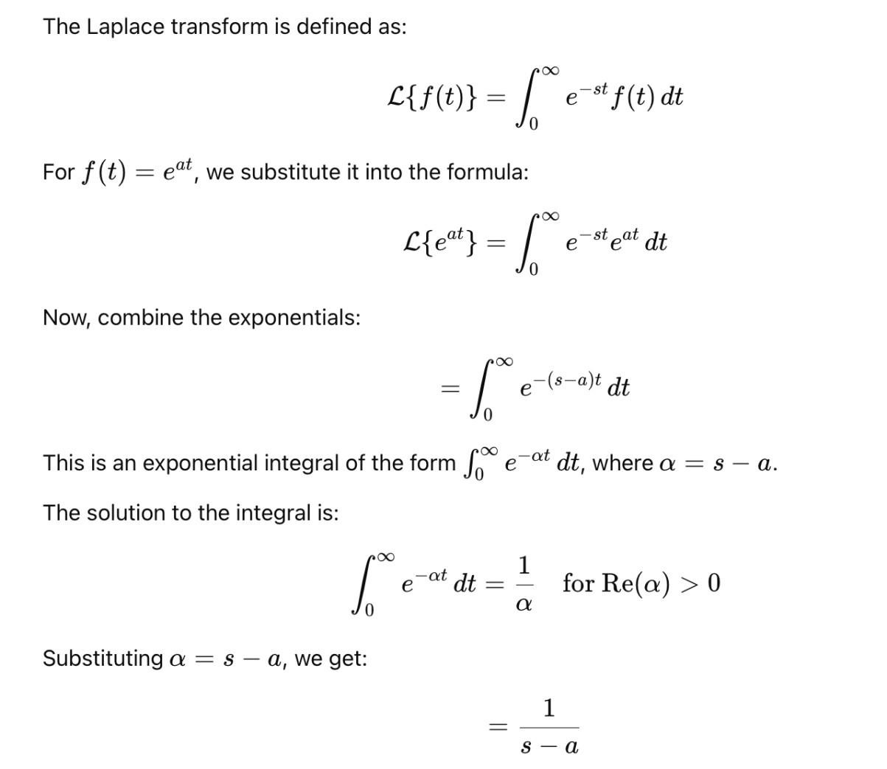

(ii)

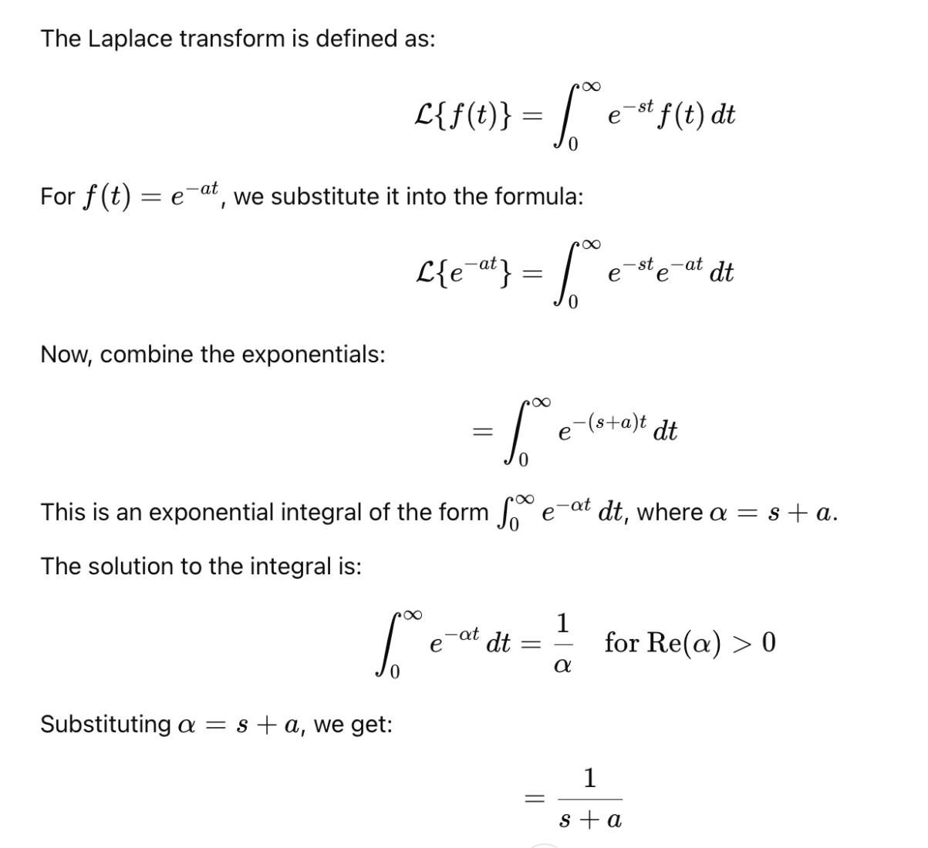 .

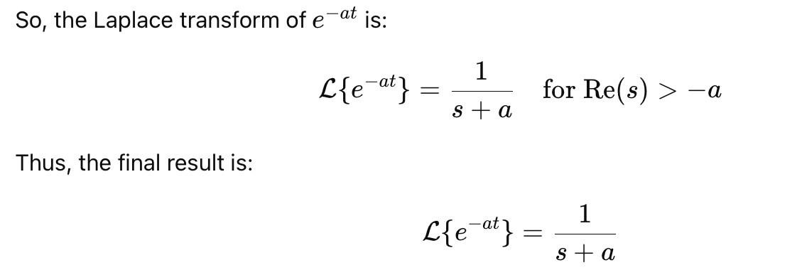

# First translation or shifting property

If L{F(t)} = f(s) then L {eat f(t)} = f(s-a)

**Proof :**

L{eat F(t)} = $\int_{0}^{∞}{e^{−st}e^{at}f(t)dt}$

= $\int_{0}^{∞}{e^{−(s−a)t}f(t)dt}$

= f(s-a)

# Second translation

If L{f(t)} = f(s) and G(t)= $\left\{\begin{aligned}f\left(t−a\right);t>a \\ 0;t<a\end{aligned}\right.$

Then, L{G(t)} = e-as f(s)

# Change of scale property

If L{F(t)} = f(s) then L {f(at)} = $\frac{1}{a}$ f($\frac{s}{a}$)

**Proof:**

L{F(at)} = -st f(at) dt

= -s(u/a) f(u)

= -s(u/a) f(u) $\frac{du}{a}$

= $\frac{1}{a}$ f($\frac{S}{a}$)

**** ***Prove that:*** L{ $e^{at}\}$ = $\frac{1}{s−a}$

L{ $e^{at}\}$ = $\int_{0}^{∞}{e^{−st}e^{at}dt}$

= $\int_{0}^{∞}{e^{−(s−a)t}dt}$

= ${\left[\frac{e^{−t(s−a)}}{−(s−a)}\right]}_{0}^{α}$

= $\frac{−1}{\left(s−a\right)}(e^{}−e^{0})$

= $\frac{−1}{\left(s−a\right)}(0−1)$

= $\frac{1}{\left(s−a\right)}$

# Laplace Transform of Derivatives

## Example:

Given that $L\left\{F\left(t\right)\right\}\text{=f}\left(s\right)$, then show that:

$$L\left\{\text{F′}\left(t\right)\right\}\text{=sf}\left(s\right)−F\left(0\right)\text{.}$$

## Solution:

Given that $L\left\{F\left(t\right)\right\}\text{=f}\left(s\right)$... (1)

By the definition of the Laplace transform, we get:

$$L\left\{\text{F′}\left(t\right)\right\}=\int_{0}^{∞}{e^{−\text{st}}}\text{F′}\left(t\right)\text{dt}\text{.}$$

Using integration by parts:

$$L\left\{\text{F′}\left(t\right)\right\}={\left[e^{−\text{st}}F\left(t\right)\right]}_{0}^{∞}\text{+s}\int_{0}^{∞}{e^{−\text{st}}}F\left(t\right)\text{dt}\text{.}$$

Since $e^{−∞}=0$:

$$L\left\{\text{F′}\left(t\right)\right\}=0−e^{0}F\left(0\right)\text{+s}\int_{0}^{∞}{e^{−\text{st}}}F\left(t\right)\text{dt,}$$

$$L\left\{\text{F′}\left(t\right)\right\}=−F\left(0\right)\text{+sf}\left(s\right)\text{.}(\text{Using equation }(1))$$

Thus:

$$L\left\{\text{F′}\left(t\right)\right\}\text{=sf}\left(s\right)−F\left(0\right)\text{.}(\text{Proved})$$

## Key Equations:

## First-Order Derivative:

The Laplace transform of the first derivative is given by:

$$L\left\{\text{F′}\left(t\right)\right\}\text{=sf}\left(s\right)−F\left(0\right)\text{.}$$

## Second-Order Derivative:

The Laplace transform of the second derivative is given by:

$$L\left\{\text{F″}\left(t\right)\right\}{\text{=s}}^{2}f\left(s\right)−\text{sF}\left(0\right)−\text{F′}\left(0\right)\text{.}$$

## Third-Order Derivative:

The Laplace transform of the third derivative is given by:

$$L\left\{F^{\left(3\right)}\left(t\right)\right\}{\text{=s}}^{3}f\left(s\right)−s^{2}F\left(0\right)−\text{sF′}\left(0\right)−\text{F″}\left(0\right)\text{.}$$

## $n$-th Order Derivative:

The Laplace transform of the $n$-th derivative is given by:

$$L\left\{F^{\left(n\right)}\left(t\right)\right\}{\text{=s}}^{n}f\left(s\right)−s^{n−1}F\left(0\right)−s^{n−2}\text{F′}\left(0\right)−…−{\text{sF}}^{\left(n−2\right)}\left(0\right)−F^{\left(n−1\right)}\left(0\right)\text{.}$$

# Laplace Transform of a Function Divided by $t$

**Example:** If $L\left\{F\left(t\right)\right\}\text{=f}\left(s\right)$, then:

$$L\left\{\frac{F\left(t\right)}{t}\right\}=\int_{s}^{∞}{f}\left(u\right)\text{du}\text{.}$$

# Laplace Transform of Integrals

**Example:** If $L\left\{F\left(t\right)\right\}\text{=f}\left(s\right)$, then:

$$L\left\{\int_{0}^{t}{F}\left(u\right)\text{du}\right\}=\frac{f\left(s\right)}{s}\text{.}$$

$$L\left\{\int_{0}^{t}{\frac{\text{sin}u}{u}}\text{du}\right\}=\frac{1}{s}{\text{tan}}^{−1}\frac{1}{s}\text{.}$$

# Laplace Transform of Integrals and Inverse Laplace Transform

# Laplace Transform of Integrals

The Laplace transform of a function f(t) is defined as:  
 𝓛{f(t)} = F(s) = ∫₀^∞ e^(-st) f(t) dt  
  
If F(s) = 𝓛{f(t)}, then the Laplace transform of the integral of f(t) from 0 to t is:  
 𝓛{∫₀^t f(τ) dτ} = F(s)/s  
  
This result is especially useful in solving integral equations and analyzing systems where accumulation over time plays a role.

# Inverse Laplace Transform

The inverse Laplace transform retrieves the original time-domain function f(t) from its Laplace transform F(s), denoted as:  
 𝓛⁻¹{F(s)} = f(t)  
  
While a general formula does not exist for all functions F(s), many common functions have known inverse transforms. Methods for finding inverse Laplace transforms include partial fraction decomposition, convolution theorem, and the complex Bromwich integral.

# Key Properties

1. Linearity:  
 𝓛{af(t) + bg(t)} = aF(s) + bG(s)  
  
2. Shifting in Time Domain:  
 𝓛{f(t - a)u(t - a)} = e^(-as)F(s)  
  
3. Differentiation in Time Domain:  
 𝓛{f'(t)} = sF(s) - f(0)  
  
4. Integration in Time Domain:  
 𝓛{∫₀^t f(τ) dτ} = F(s)/s  
  
5. Final Value Theorem (if the limit exists):  
 lim_{t → ∞} f(t) = lim_{s → 0} sF(s)  
  
6. Initial Value Theorem:  
 lim_{t → 0⁺} f(t) = lim_{s → ∞} sF(s)  
  
These tools are essential for analyzing dynamic systems, especially in engineering, physics, and control theory.

# Example 7 : Solving a Differential Equation Using Laplace Transform

Given Differential Equation:

Y''(x) - Y'(x) = x

Initial Conditions: Y(0) = 2, Y'(0) = 3

## Step 1: Apply Laplace Transform

Taking Laplace transform on both sides of the equation:

L{Y''(x)} - L{Y'(x)} = L{x}

Using Laplace properties:

s²Y(s) - sY(0) - Y'(0) - (sY(s) - Y(0)) = 1/s²

Substitute Y(0) = 2, Y'(0) = 3:

s²Y(s) - 2s - 3 - (sY(s) - 2) = 1/s²

Simplifying: (s² - s)Y(s) = 1/s² + 2s + 1

## Step 2: Solve for Y(s)

Y(s) = (1 + 2s³ + s²) / [s³(s - 1)]

## Step 3: Partial Fraction Decomposition

We decompose the function:

Y(s) = A/s + B/s² + C/s³ + D/(s - 1)

Using algebraic expansion and comparison with the numerator, we find:

A = -1, B = -1, C = -1, D = -2

Therefore:

Y(s) = -1/s - 1/s² - 1/s³ - 2/(s - 1)

## Step 4: Take Inverse Laplace Transform

Using inverse Laplace rules:

L⁻¹{-1/s} = -1

L⁻¹{-1/s²} = -x

L⁻¹{-1/s³} = -x²/2

L⁻¹{-2/(s - 1)} = -2e^x

## Final Answer:

Y(x) = 4 - x - 1/x² - 2e^x

**Example 8: Solving Differential Equation using Laplace Transform**

Given equations are:  
Y''(t) + 9Y(t) = cos(2t)     ...(1)  
Y(0) = 1, Y(π/2) = -1        ...(2)  
  
**Taking Laplace transform of (1):**L{Y''(t)} + 9L{Y(t)} = L{cos(2t)}  
⇒ s²Y(s) - sY(0) - Y'(0) + 9Y(s) = s / (s² + 4)  
  
Using Y(0) = 1 and let Y'(0) = a, we get:  
s²Y(s) - s - a + 9Y(s) = s / (s² + 4)  
⇒ (s² + 9)Y(s) = s / (s² + 4) + s + a  
  
So,  
Y(s) = [s / (s² + 4) + s + a] / (s² + 9)  
     = s / [(s² + 4)(s² + 9)] + s / (s² + 9) + a / (s² + 9)  
     = 5s / [(s² + 4)(s² + 9)] + s / (s² + 9) + a / (s² + 9)  
  
**Now taking inverse Laplace transform:**  
Y(t) = L⁻¹{5s / [(s² + 4)(s² + 9)]} + L⁻¹{s / (s² + 9)} + aL⁻¹{1 / (s² + 9)}  
     = (1/5)cos(2t) + (4/5)cos(3t) + (a/3)sin(3t)       ...(2)  
  
Using Y(π/2) = -1, substitute t = π/2 in (2):  
Y(π/2) = (1/5)cos(π) + (4/5)cos(3π/2) + (a/3)sin(3π/2)  
      = (1/5)(-1) + (4/5)(0) + (a/3)(-1)  
      = -1/5 - a/3  
  
Set equal to -1:  
-1/5 - a/3 = -1  
⇒ a/3 = 4/5  
⇒ a = 12/5  
  
**Substitute a into (2):**Y(t) = (1/5)cos(2t) + (4/5)cos(3t) + (4/5)sin(3t)

**Theorem-1: If $f\left(x\right)=\frac{a_{0}}{2}+\sum_{n=1}^{∞}{\left(a_{n}cos\left(nx\right)+b_{n}sin\left(nx\right)\right)}$,Then it can be shown that:**

(i) $a_{0}=\frac{1}{π}\int_{−π}^{π}{f\left(x\right)}dx$

(ii) $a_{n}=\frac{1}{π}\int_{−π}^{π}{f\left(x\right)}cos\left(nx\right)dx$

(iii) $b_{n}=\frac{1}{π}\int_{−π}^{π}{f\left(x\right)}sin\left(nx\right)dx$

**Ans**:

$⟹$ Given that:

$f\left(x\right)=\frac{a_{0}}{2}+\sum_{n=1}^{∞}{\left(a_{n}cos\left(nx\right)+b_{n}sin\left(nx\right)\right)}$--------(1)

(i) Now integrating both sides for (1) w.r. to x between the limits - $π$ and $π$ then we get

$\int_{−π}^{π}{f\left(x\right)}dx=\frac{a_{0}}{2}\int_{−π}^{π}{dx}+\sum_{n=1}^{∞}{a_{n}\int_{−π}^{π}{cosnxdx}}+\sum_{n=1}^{∞}{b_{n}\int_{−π}^{π}{sinnxdx}}$

$⇒$ $\int_{−π}^{π}{f\left(x\right)}dx$ = $\frac{a_{0}}{2}$ + $\sum_{n=1}^{∞}{a_{n}.0}+\sum_{n=1}^{∞}{b_{n}}.0$

$⇒$ $\int_{−π}^{π}{f\left(x\right)}dx$ = $a_{n}.π+0$

$⇒a_{n}$**= $\frac{1}{π}\int_{−π}^{π}{f\left(x\right)}dx$**

(ii) Again multiplying both sides of (1) by cosnx and then integrating w.r. to x between the limits - $π$ and $π$, we get

$\int_{−π}^{π}{f\left(x\right)cosnx}dx$ = $\frac{a_{0}}{2}\int_{−π}^{π}{cosnx}dx+a_{n}\int_{−π}^{π}{\cos^{2}nx}dx$ [as other integral is zero]

$⇒$ $\int_{−π}^{π}{f\left(x\right)cosnx}dx$ = 0 + = $\frac{a_{n}}{2}\int_{−π}^{π}{(1+cos2nx)dx}$

$⇒$ $\int_{−π}^{π}{f\left(x\right)cosnx}dx$ = $\frac{a_{n}}{2}$

$⇒$ $\int_{−π}^{π}{f\left(x\right)cosnx}dx$ = $\frac{a_{n}}{2}$ (2 $π)$

$⇒$ $a_{n}=\frac{1}{π}\int_{−π}^{π}{f\left(x\right)}cosnxdx$**.**

(iii) ) Also multiplying both sides of (1) by sinnx and then integrating w.r. to x between the limits - $π$ and $π$, we get

$\int_{−π}^{π}{f\left(x\right)sinnx}dx$ = $\frac{a_{0}}{2}\int_{−π}^{π}{sinnx}dx+b_{n}\int_{−π}^{π}{\sin^{2}nx}dx$ [as other integral is zero]

$⇒$ $\int_{−π}^{π}{f\left(x\right)sinnx}dx$ = 0 + = $\frac{b_{n}}{2}\int_{−π}^{π}{(1−cos2nx)dx}$

$⇒$ $\int_{−π}^{π}{f\left(x\right)sinnx}dx$ = $\frac{b_{n}}{2}$

$⇒$ $\int_{−π}^{π}{f\left(x\right)sinnx}dx$ = $\frac{b_{n}}{2}$ (2 $π)$

$⇒$ $b_{n}=\frac{1}{π}\int_{−π}^{π}{f\left(x\right)}sinnxdx$

Theorem-2 If f(x) is an even function then show that,

1. a0 =

We know,

an =

=…..(1)

In the first integral of (1) we put x = -y then dx = -dy

Limit:If x = -π ,then -π = -y ⇒ y = c

If x = 0 ,then 0 = -y ⇒ y = 0

∴ $\int_{π}^{0}{f\left(ϰ\right)ⅆx}$ =- $\int_{π}^{0}{f\left(−y\right)ⅆy}$

= $\int_{0}^{π}{f\left(−y\right)ⅆy}$

= $\int_{0}^{π}{f\left(−ϰ\right)ⅆx}$: Since $\int_{a}^{b}{f\left(ϰ\right)ⅆx}$ = $\int_{a}^{b}{f\left(y\right)ⅆy}$

= $\int_{0}^{π}{f\left(ϰ\right)ⅆx}$……(2) Since f(x) is an even function,

Now from (1) and (2) we get

a0 =

⇒ a0 =  .

# Dirichlet’s Conditions

A function  defined on the interval  satisfies Dirichlet’s conditions if:

1.  is single-valued and bounded in ,
2.  has only a finite number of discontinuities,
3.  has only a finite number of maxima and minima,
4.  is absolutely integrable over one period:

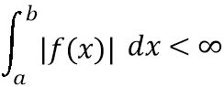

These conditions ensure the convergence of the Fourier series.

# Fourier Integral Theorem

If  satisfies Dirichlet’s conditions on , it can be represented as:

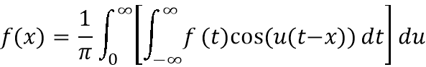

Or in exponential form:

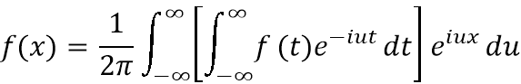

This expresses  as a continuous sum of sine and cosine (or complex exponential) terms.

# Even and Odd Functions

* **Even Function:** If , then only cosine terms appear in its Fourier series.
* **Odd Function:** If , then only sine terms appear in its Fourier series.

Choosing even or odd extensions simplifies Fourier analysis.

# The Finite Fourier Sine Transform

Let  be defined in the interval .

The finite Fourier sine transform is:

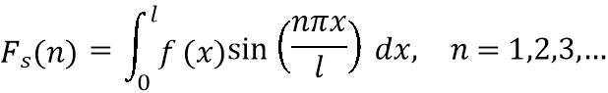

The inverse transform (to recover ) is:

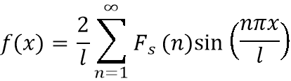

This is useful in solving PDEs with boundary conditions like .

# The Finite Fourier Cosine Transform

Let  be defined in the interval .

The finite Fourier cosine transform is:

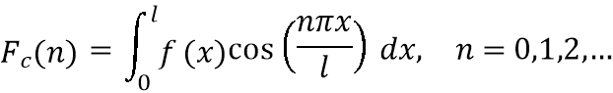

The inverse transform (to recover ) is:

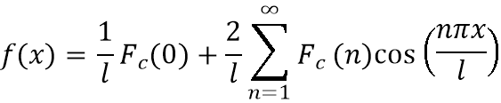

# The Fourier Sine Transform

Let  be defined for .

The Fourier sine transform is:

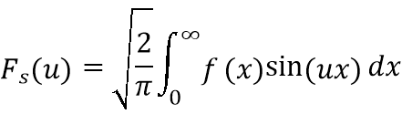

The inverse Fourier sine transform is:

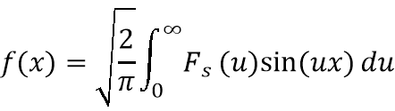

# The Fourier Cosine Transform

Let  be defined for .

The Fourier cosine transform is:

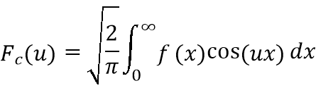

The inverse Fourier cosine transform is:

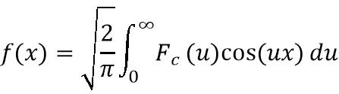

# The Fourier Transform

Let  be defined for .

The Fourier transform is:

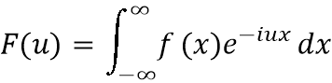

The inverse Fourier transform is:

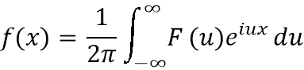

# Relation between Fourier and Laplace transforms

We consider a function

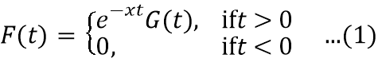

Then,

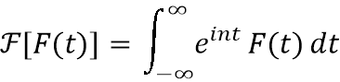

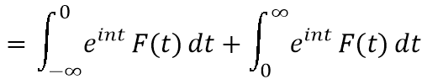

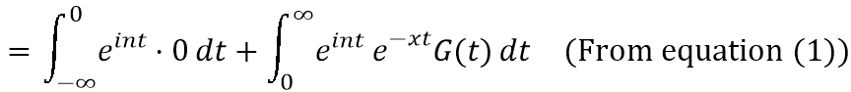

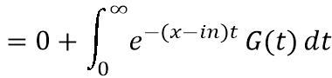

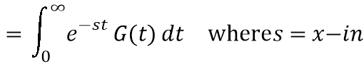



**Which is the required relation between Fourier and Laplace transforms.**

**Application of Fourier Transformation**

If U = U(x, t), $\frac{∂^{}u}{∂t^{}}=\frac{∂^{2}U}{∂x^{2}}$, v(0, t) = 1 , U(x, t) = 3, U(x, 0) = 1 then find the value of U.

Solve:

$$givenequations:$$

$$\frac{∂x}{∂U}=\frac{∂x2}{∂2U}………………1$$

$$U\left(0,t\right)=1……………(2)$$

$$U\left(x,t\right)=3……..\left(3\right)$$

$$U\left(x,0\right)=1……..\left(4\right)$$

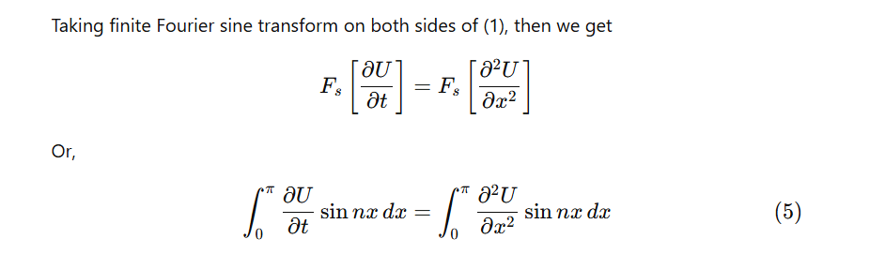

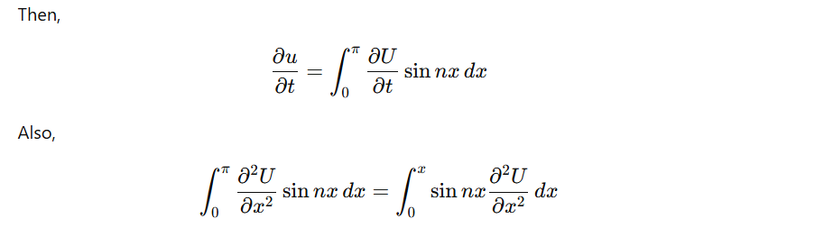

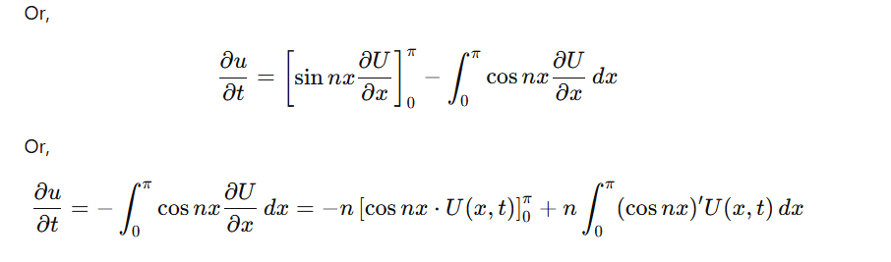

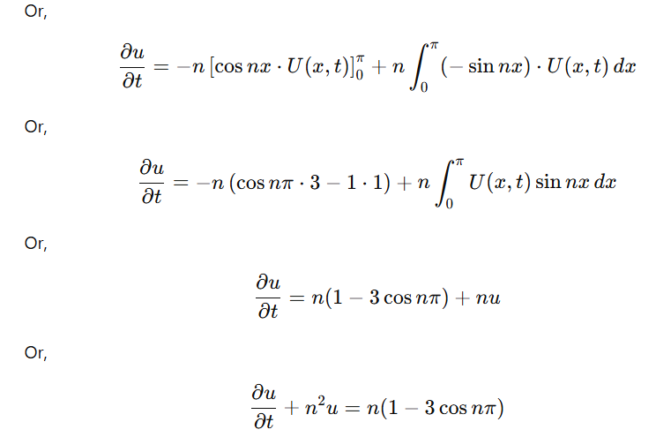

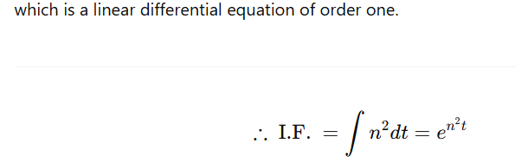

Multiplying (7) by en2te^{n^2 t}en2t, we get

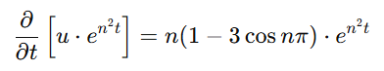

Integrating both sides w.r.t. ttt, then we get,

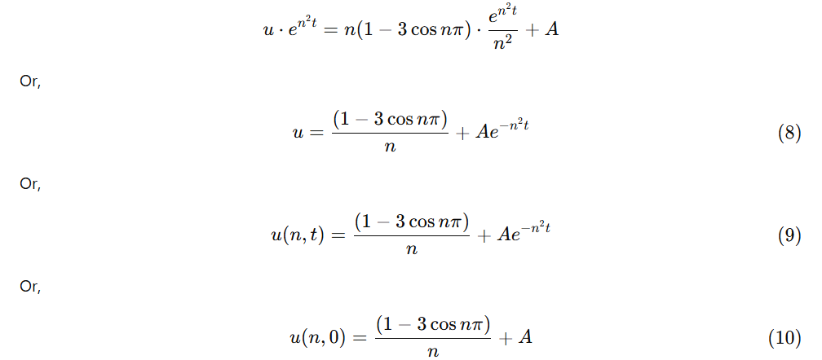

Now putting t=0 in (6), then we get

or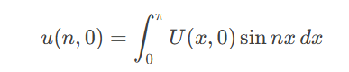

or

or 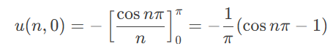

or 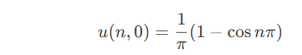

or 

or 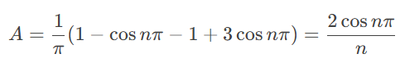

putting the value of A in , we get

